

**Salesforce.com Knowledgebase Integration Functional Design**

Version 1.7

July 6, 2015

**Copyright © 2015 Unisys Corporation**

**All rights reserved**

**Unisys Corporation Confidential**

**Revision History**

|  |  |  |  |
| --- | --- | --- | --- |
| Version | Date | Author | Summary of Changes |
| 1.0 | 1/22/2014 | Sreelatha SK | Initial draft |
| 1.1 | 2/05/2014 | Sreelatha SK  M. Schmidt | Updated document |
| 1.2 | 2/11/2014 | M. Schmidt  Sreelatha SK | Updated fields |
| 1.3 | 2/27/2014 | Sreelatha SK | Added fields based on requirements from Graham |
| 1.4 | 4/29/2014 | Sreelatha SK | Modified data type for Author, Modified Date, Available Date and Related Articles |
| 1.5 | 5/19/2014 | M Schmidt | Updated fields for display and business rules. |
| 1.6 | 9/9/2014 | M Schmidt | Updated fields and aliases. |
| 1.7 | 6/7/2015 | Sreelatha SK/ Hari Krishna Kousik Ogirala | Updated the Article Rating by replacing Like/Unlike with Stars Rating for PKB |

**Reviewers**

| Name | Position |
| --- | --- |
|  |  |
| Kimberly Adams | City – Knowledge Base SME |
| Edward Garcia | City – Project Manager |
| Sheryl Johnson | City – 311 Director |
|  |  |
|  |  |
|  |  |
|  |  |
|  |  |

Table of Contents

Table of Contents 3

1 Overview 4

2 Article Type 4

3 Data Category Groups 5

4 Assumptions 5

5 Supporting Business Rules 6

6 Article Rating for Public Knowledgebase (PKB) 7

7 Article Example 8

8 Article Import CSV (Comma Separated Value) File 8

# Overview

This document defines the functionality needed to create the standard Knowledge Base Article Type for Call Center application on SalesForce.com. The Standard Article Type will contain multiple fields containing information with differing intended audiences and permission types. The articles may contain attachments.

# Article Type

This section defines the requirements needed to create the Standard Article Type, which provides the format and structure that controls how these articles are displayed within the Salesforce application (channel = Internal App, Partner, Custom, Public Knowledge Base).

**Fields for Article Type = FAQ Article**

|  |  |  |  |  |  |
| --- | --- | --- | --- | --- | --- |
| **Field Label** | **Field Type** | **Standard or Custom** | **History** | **Field Help Text** | **Comments** |
| **Section 1 - Standard Information** | | | | | |
|  | | | | | |
| Question | Text(255) | Standard | Yes | None | Title of the Article |
| Summary | Text Area(1000) | Standard | No | None | Description |

|  |  |  |  |  |  |
| --- | --- | --- | --- | --- | --- |
| **Field Label** | **Field Type** | **Standard or Custom** | **History** | **Field Help Text** | **Comments** |
| **Section 2 – Article Information** | | | | | |
| Department | Picklist | Custom | Yes | None | City Departments name should be listed in dropdown |
| Special Info – 311 | Text Area(255) | Custom | Yes | None | Contains temporary info available 311 Call Center agents and supervisors |
| Alert | Text Area(255) | Custom | Yes | None | Contains temporary info available all users |
| Answer | Rich Text Area(32768) | Custom | Yes | None | Contains general info with no viewing restrictions. |
| Agent Info | Rich Text Area(32768) | Custom | Yes | None | Contains agent specific info viewable by agents and supervisors |
| Supervisor Info | Rich Text Area(32768) | Custom | Yes | None | Contains supervisor specific info viewable by supervisors only. |
| City Employees Info | Rich Text Area(32768) | Custom | Yes | None | Contains information intended for departmental users viewable by the departments, agents, and supervisors. |

|  |  |  |  |  |  |
| --- | --- | --- | --- | --- | --- |
| **Field Label** | **Field Type** | **Standard or Custom** | **History** | **Field Help Text** | **Comments** |
| **Section 3 – Additional Information** | | | | | |
| Keywords | Text Area(255) | Custom | Yes | None | Supportive keywords to search Articles |
| Related Case | URL(255) | Custom | Yes | None | Contains case that may be related to an article |
| Related Articles | Rich Text Area(32768) | Custom | Yes | None | Contains articles that may be affected if this article is updated |
| Links | Rich Text Area(32768) | Custom | Yes | None |  |
| Attachments | Rich Text Area(32768) | Custom | Yes | None |  |
| Modified Date | Formula(Date/Time) | Custom | Yes | None | Formula field of the System date and time when the Article was Modified |
| Available Date | Formula(Date/Time) | Custom | Yes | None | Formula field of the date and time when the Article was Last Published |
| Author | Formula(Text Area) | Custom | Yes | None | Formula field updated based on Created By user |

# Data Category Groups

This section defines the requirements for the Data Group Category called “City of Philadelphia”. The hierarchy for this Category Group will contain child categories representing each of the city departments, which in turn may contain their own child categories. An article can be associated to none, one, or multiple categories within the Category Group. As a general practice, an article will be associated with at least one departmental category.

*<City to provide the child category details>*

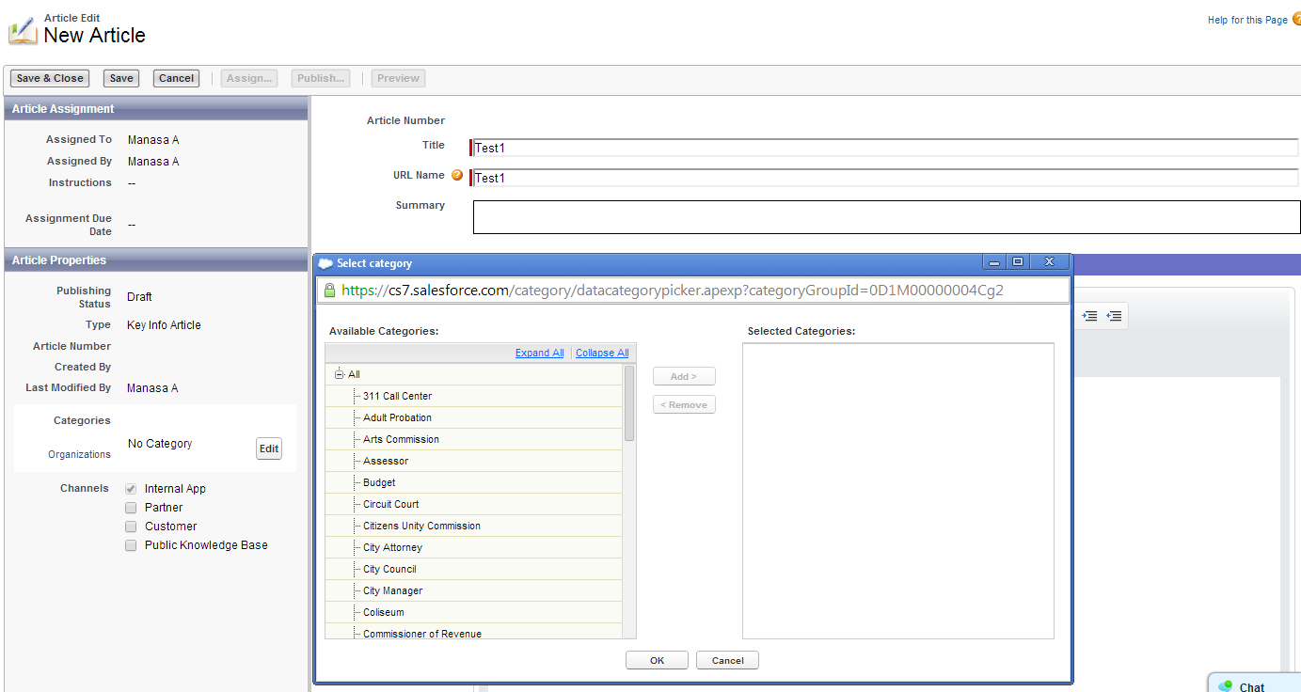

An additional hierarchy may be created to accommodate subject based inquiries. These will be organized based on the subject matter of the article, regardless of the department owning the article. An article may be assigned to one or more subject categories in addition to the departmental categories.

# Assumptions

The following table defines the assumptions of conditions that must be true for a successful implementation:

| **Assumption #** | **Assumption Description** | **Comments** |
| --- | --- | --- |
| ASSUMP1 | Special Info contains temporary information present for <*certain*> period |  |
| ASSUMP2 | Data Category will be setup during configuration, to which new articles may be associated. |  |
| ASSUMP3 | The initial categorization of articles will need to be completed manually. |  |
| ASSUMP4 | The two articles can be linked by using hyperlink to the other Article. |  |
| ASSUMP5 | Department name should be auto-populated for Information Request type base on the value present in “**Department**” field. |  |

# Supporting Business Rules

The following defines the additional business rules needed to support the import of FAQs from the Novo CRM application into corresponding Knowledgebase “Articles” within Salesforce:

| **Rule #** | **Business Rule Description** | **Comments** |
| --- | --- | --- |
| BRULE001 | Field labels should only be visible to users that have permission to view the field data. |  |
| BRULE002 | **Department** field contains picklist of City Departments | This includes Neighborhood Services, Police, and Streets for the Pilot. |
| BRULE003 | **Special Info** data should only be visible to   * 311 Agents * Supervisors |  |
| BRULE004 | **Special Info - 311** field should have the Expiration duration. Based on expiration set, the temporary data stored to be deleted from database. |  |
| BRULE004 | **Special Info - Public** field should have the Expiration duration. Based on expiration set, the temporary data stored to be deleted from database. |  |
| BRULE005 | **Special Info – Public** should be visible to all users. |  |
| BRULE006 | **Public Info** data should only be visible to all users. | This data should be visible to all Knowledge Base users. |
| BRULE007 | **Agent Info** data should only be visible to   * 311 Agents * Supervisors |  |
| BRULE008 | **Supervisor Info** data should only be visible to   * Supervisors |  |
| BRULE009 | **City Employees Info** data should only be visible to   * Salesforce internal users * Partner Portal Users * 311 Agents * 311 Supervisors |  |
| BRULE010 | **Keywords** data should only be Visible to   * Supervisors * 311 Agents |  |
| BRULE011 | **Attachments, Modified Date, Available Date, Service Request, Topic#1, Topic#2, Topic#3, Topic#4, Topic#5, Topic#6, Topic#7, OIT High Level Hierarchy** data should be Visible to   * 311 Agents * Supervisors * Public users | This data should be visible to All |
| BRULE012 | **Author** data should only be Visible to   * Knowledgebase Administrator |  |
| BRULE013 | Email communication should only contain “Public Info” data |  |
| BRULE014 | User can subscribe to articles to be notified of any changes or updates. |  |
| BRULE015 | **Data Category** field should be associated with every Article |  |
| BRULE016 | **Modified Date** is visible to all users |  |
| BRULE017 | **Related Articles** should only be visible to Knowledge Base administrators |  |

# Article Rating for Public Knowledgebase (PKB)

Article Rating for PKB – Replace the rating style of PKB in sync to internal KB.

PKB Rating



Internal KB Rating

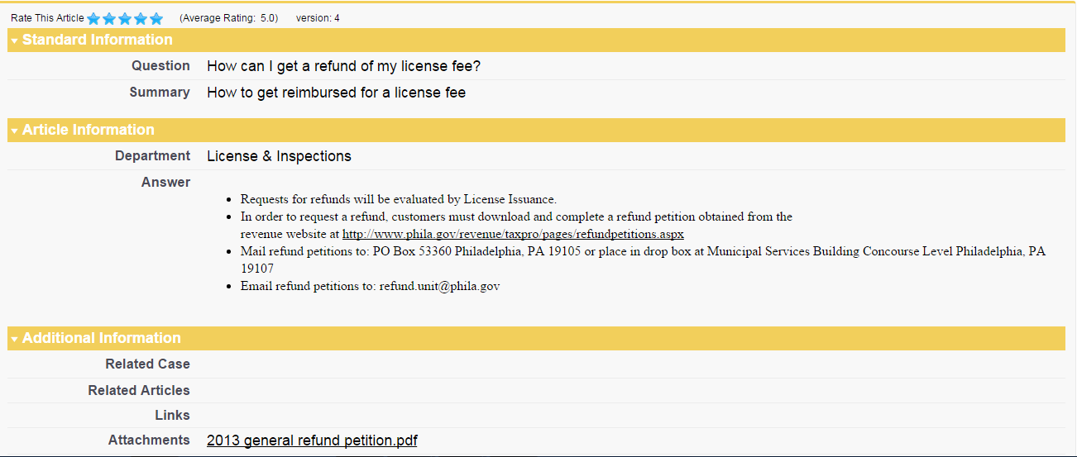

* *Feature:* *Rating features in PKB from Like/Unlike to Star Rating*

The PKB article rating style has to be changed according to the internal rating style

* *Feature: Link all the articles to custom object to add ratings*

The articles present in salesforce have to be linked to a custom object so that the ratings given by non Salesforce users (PKB users) are captured and stored in the custom object.

* *Feature: Create a report type for reporting on the ratings*

A custom report type has to be created for reporting on the ratings on each article

# Article Example

This section provides an example of the Salesforce Article page.

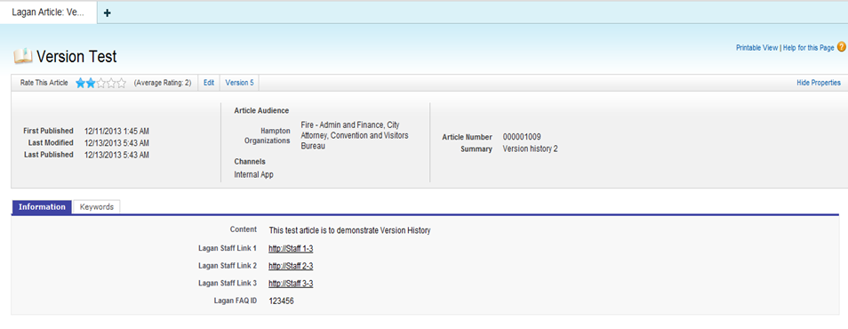

Version history is viewed by selecting the Version X tab, where X is the most current version number.

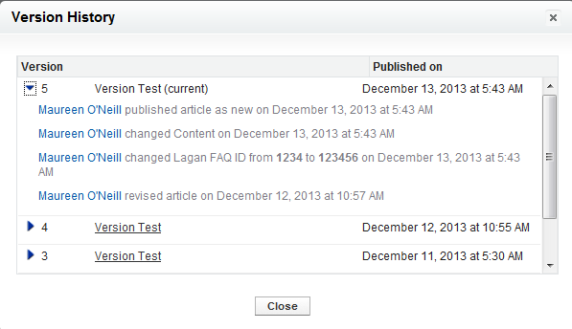

# Article Import CSV (Comma Separated Value) File

This section is required for importing Knowledge Base Articles from Novo database into SFDC. The dump will be taken in csv (comma separated value) format from Novo database. Novo data dump cleanup is not in scope with Unisys.

Unisys will send the “Novo”.csv template for importing data dump from current Novo CRM application, which will be verified for test records. Unisys will delete all test articles from Philadelphia Sandbox before actual import is done.

The knowledge articles imports will be done for FAQ article type. If the city requires any other fields to be imported, this layout will need to be revised. The city provides the “Novo_KB”.csv file for importing the Novo dump for knowledgebase records. The import template should be provided in format as specified below:

